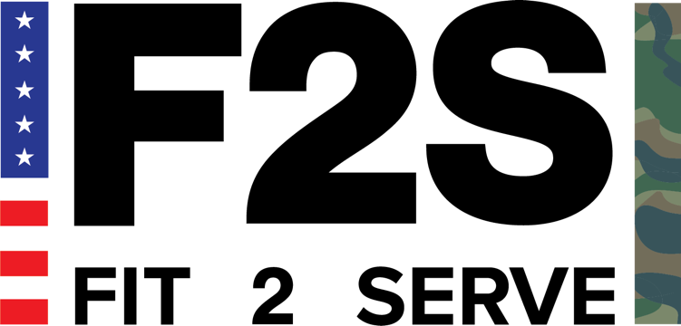

Testimonial and Photo Release Form

In consideration of good and valuable consideration, the receipt and sufficiency of which is hereby acknowledged, I, the undersigned, hereby grant to Fit 2 Serve the right to use my name, biographical information, photographs, images, story and/or testimonial, in whole or in part, and without restriction as to changes or alterations. The rights granted herein shall extend in perpetuity, unless revoked in writing through certified mail to Fit 2 Serve by me, throughout the world and for any purpose whatsoever, including without limitation for marketing and advertising purposesof Fit 2 Serve, and in any and all media and social media, including without limitation Fit 2 Serve's website. I acknowledge that Fit 2 Serve has no obligation to return any photographs or images to me.

I hereby RELEASE, WAIVE and FOREVER DISCHARGE any and all claims arising out of, or
in connection with such use by Fit 2 Serve, including, but not limited to, any and all claims libel, slander, conversion, unjust enrichment or invasion of privacy.

I hereby warrant and represent that I am at least 18 years of age, am of sound mind, and have the right to contract in my own name. I have read the above release and am fully familiar with the contents thereof. This Release contains the entire agreement between the parties as to the subject matter contained herein.

_________________________________________
Participant's Name Printed

_________________________________________ ____________________
Participant's Signature Date

